**Maven installation:**

Copy the link of tar file and download it with wget command

* **Sudo wget <URL>**

Then extract the tar file

* **Tar -zxvf <file>**

After extraction, we need to give maven bin location as MVN_HOME in bash file

* Once we build it, it will create .m2 folder as local repo

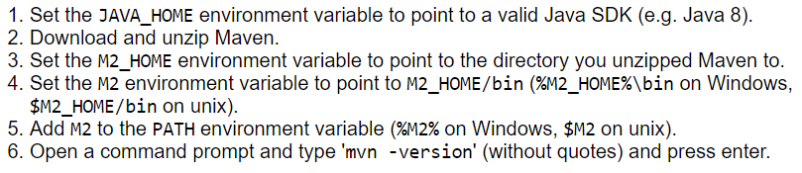

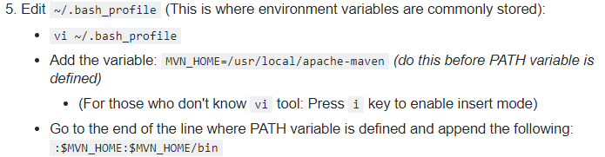

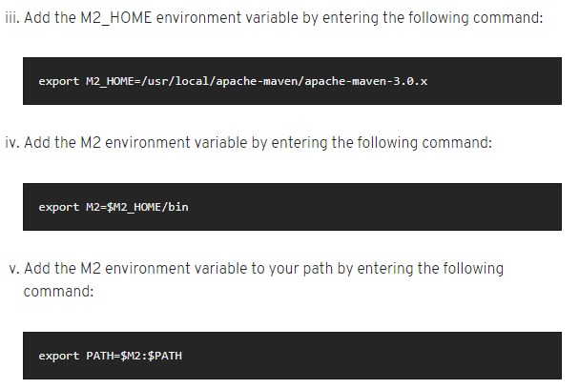

* Download maven and set environment variables

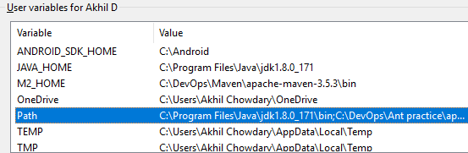

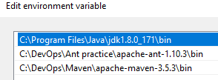

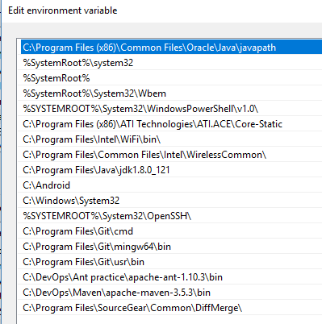

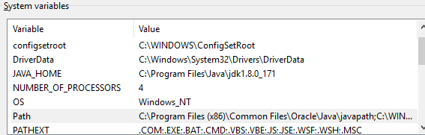

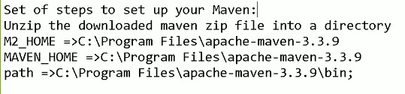

* Java also should be set
* We must need access to the maven home to run the maven

